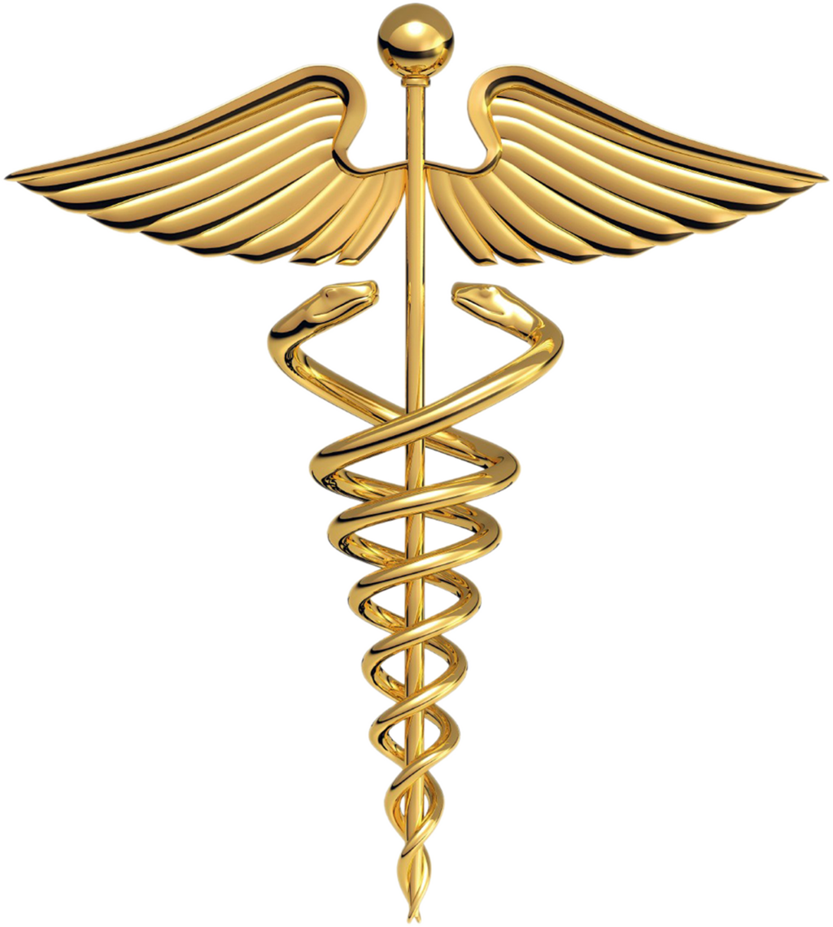Colorado College Health Professions Advising_____ 
Quick Tips for Pursuing a Health Profession

- Access Health Professions Advising via Advising Hub webpage
https://www.coloradocollege.edu/other/advising-hub/
- Meet with staff advisor each semester to discuss plans for pursuing a health profession.
- Choose a major in any subject you enjoy. You do not have to major in a science.
- Maintain a 3.5 GPA to be competitive.
- If GPA is lower, consider applying to a Post-Bac or Master’s Program to improve application.
- Take Pre-requisite courses:
  - Biology – 1 intro course: BE105, BE106, BE107 (your choice)(counts as 1 lecture & 1 lab)
  - Cell Biology – 2 intro courses: MB131 and MB201(counts as 1 lecture & 1 lab)
  - General Chemistry – 2 courses: CH107, CH108
  - Organic Chemistry: 2 courses :CH250, CH251
  - Physics – 2 courses: PC141, PC142 or PC241, PC242 (Calc. based)
  - English – 2 courses: 1 literature course and 1 writing intensive course.
- Required Courses for the MCAT:
  - Biochemistry – 1 course: CH382
  - Math – 2 courses: Probability & Statistics MA117,; Pre-Calc – Calc MA125; Calculus 1 MA126, Calculus 2 MA129 (any 2, but MA117 recommended)
  - Psychology – 1 course: PY100
- Highly Recommended courses include:
    - Genetics MB231
    - Basic Anatomy HK204
    - Human Physiology HK321
- Do not take prerequisite courses pass/fail
- Utilze stellic
- Sign-up for Pre-Health mailing list for information about speakers, Health Professions Club, and volunteer and internship opportunities.
- Join the Health Professions Club, Pre-Vet Club, MAPS, Glob Med and other organizations of interest.
- Develop leadership skills through organizations and clubs.
- Get experience in the field of health care. Can acquire licenses i.e.: CNA, EMT, MA, Phlebotomist, Rehab Aid, etc..
- Get experiences shadowing professionals in that field (Physicians, Dentists, Vets, etc.
- Get community service experience (i.e.; homeless shelters, habitat for humanity, soup kitchen, foundations, etc.)
- Get research experience.
- Request letters of evaluation from Professors, Physicians and Supervisors.
- Take MCAT, DAT, GRE - earliest would be spring or summer of junior year.
- AP/IB credits transfer, but need to take higher-level courses in that department.
- Apply end of junior year (at the earliest). One to two years post-graduation with meaningful work experience is helpful.
- Medical admissions favor those who apply early in the application cycle due to rolling admissions. Applications usually open April (PA); May (DO); early June (MD, Dental, Vet); July (PT)

FAQ’s
- What is the acceptance rate for Med, Vet, Dental etc. schools at CC?
For the 2017-18 Application year: 28 students applied to MD and DO school; 23 had interviews and 21 were accepted = 88%acceptance rate; 2 students applied to Dental school and were accepted= 100%acpetance rate; 3 Students applied to Vet school and were accepted= 100%acceptance rate; 1 applied to PA school and was accepted= 100%acceptance rate.

- What are the Medical Schools that accept our students?
Acceptances include: Creighton, University of Colorado, Duke, Emory, Georgetown, Harvard, Loyola, Northwestern, Oklahoma, University of Michigan, University of Arkansas, University of Minnesota, USC, University of Missouri, Oregon Health and Science University, Tulane, University of Washington, University of Vermont, University of Chicago, Rochester, St. Louis, University of Texas, Brown, Case Western, Einstein, University of Miami, Tufts, Yale, Mt. Sinai, Stanford, Drexel, Penn State, Thomas Jefferson, Hawaii, Utah, FIU, Texas Tech, Mayo Clinic, Dartmouth, George Washington, Baylor, New York Medical College, University of Wisconsin and many more.

- Can I take required courses at a community college or online?
Most Med, Dental and Vet schools prefer the required courses to come from a 4-year institution. It varies from school to school regarding online courses and community college courses. The student will need to check the school of interest for specifics.

- Do I have to major in Biology or Chemistry to apply to med, vet or dental school?
No, actually many medical schools prefer non-science majors as it exhibits a well-rounded understanding of many curricular areas.

- Will my AP courses count toward the required courses for my desired Health Profession Program?
It depends on each school. Many will prefer you to take an upper level course at the undergraduate level.

- How many CC students apply directly into medical school without a gap year?
Usually only 2-3 students apply directly into any of the health professional programs. Most of our applicants apply to these programs anywhere from 1 to 5 years post-graduation.
For more information, contact Jane Byrnes, Health Professions Advising Manager, jbyrnes@coloradocollege.edu

