Children’s Center Curriculums

Reggio Emilia Inspired Curriculum- This curriculum model fosters children’s intellectual development through a systematic focus on symbolic representation. Young children are encouraged to explore their environment and express themselves through all of their available “expressive, communicative, and cognitive languages”. The partnership among parents, educators, and children is necessary. Classrooms are organized to support a highly collaborative, problem-solving approach to learning. Education is seen as a communal activity and a sharing of culture through joint exploration among children and adults. This method promotes new ways to think about the nature of the child as a learner, the role of the teacher, the school organization and management, the design and use of physical environment and curriculum planning that guides expression of joint, open-ended discovery and constructive posing and solving of problems. Inherent in this approach is a focus on a welcoming, open, community space available for multiple uses. The environment is seen as the “third teacher”. The aesthetics of the environment are very important. Much thought is put into the use of light, colors, and textures in the classroom designs and displays.

Natural Environment Curriculum- Teachers provide intentional outdoor experiences and create spaces that give children the opportunity to better understand and appreciate the natural world. Children who have the opportunity to spend time in well-designed outdoor spaces develop skills across all learning domains. Teachers foster and celebrate the intellectual, physical, social and emotional growth that takes place for every child every day in the natural outdoor classroom. Research links our mental, physical, and spiritual health directly to our association with nature. By allowing the young child access to the outdoors they gain competence in moving through the larger world.

Emergent Curriculum- Emergent curriculum describes a curriculum that develops from exploring what is socially relevant, intellectually engaging, and personally meaningful to children. The curriculum philosophy unites children’s budding interests with the educational framework constructed by the teachers based on their professional training and experience. Emergent curriculum arises naturally from adult-child and child-child interactions that create “teachable moments.” It connects learning with experience and prior learning. It responds to children’s immediate interests rather than focusing on a narrow, individual, or calendar driven topic. It is process rather than product driven. The curriculum is typically implanted after an idea emerges from the group of children.

Social Emotional Curriculum- Social Emotional curriculum involves children learning skills relating to the recognition of their feelings, their response to their feelings in appropriate ways and self regulation of their emotions. The development of these skills enables a child to form and engage in positive social interactions with peers and adults. It helps children develop a sense of competence and positive attitudes toward learning, forming relationships, solving everyday problems, learning ways to resolve conflict and develop empathy for others.

Constructivist Inspired Curriculum- The curriculum is presented whole to part with emphasis on big concepts. The pursuit of children’s questions is highly valued. Curricular activities rely heavily on primary sources of data and manipulative materials. Children are viewed as thinkers with emerging theories about the world. Teachers seek the children’s points of view in order to understand their present conceptions for use in subsequent lessons. Assessment of children’s learning is interwoven with teaching and occurs through teacher observations of children at work and through children exhibitions and portfolios. Children primarily work in groups.

Direct Instruction Curriculum- The teacher provides the children with much of the information they need, often through explanations, examples, and problem solving. The main strength of direct instruction is that it is efficient, especially in quickly providing information to the children. It is also an effective way to allow children to achieve mastery when learning fundamental facts, rules, or sequences. Most direct instruction techniques only allow for minimal students-teacher interaction, and need to be supplemented by review, practice, and group discussion. The teaching staff often uses this style of curriculum during topics such as fire safety and classroom/playground rules and procedures.

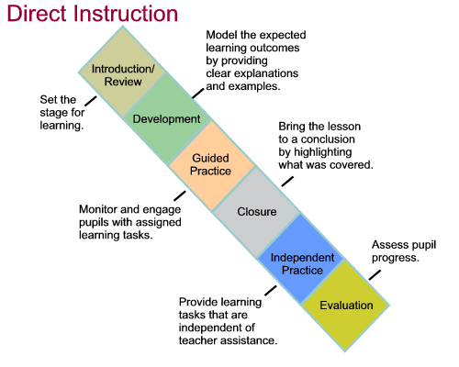
http://www.worksheetlibrary.com/teachingtips/directinstruction.html

Colorado College Children’s Center Curriculum References

- Edwards, Gandini, Forman. Hundred Languages of Children – The Reggio Emilia Approach – Advance Reflections
Julianne P. Wurm. Working in the Reggio Way

2. Richard Louv. Last Child in the Woods
Mary S. Rivkin. The Great Outdoors
National Arbor Day Foundation and Dimensions Educational Research
Foundation. Learning with Nature Idea Book

- Elizabeth Jones and John Nimmo. Emergent Curriculum
Susan Stacey. Emergent Curriculum in Early Childhood Settings

- Ann Epstein. The Intentional Teacher
Ann Epstein. Me, You, Us Social – Emotional Learning in Preschool

- Jacqueline Greennon Brooks. The Case for Constructivist Classroom

6. Direct Instruction
http://www.worksheetlibrary.com/teachingtips/directinstruction.html

