

Contact:
Brendan Boepple
(719) 227-8145
Brendan.Boepple@ColoradoCollege.edu

COLORADO COLLEGE ALUMNI BEGIN RIVER EXPEDITION
ABOARD SOLAR-POWERED RAFT

COLORADO SPRINGS, Colo. – August 20, 2012 – Four Colorado College researchers have begin the next segment of their Colorado River expedition, crossing the inland sea of Lake Powell and then continuing on to explore the depths of the Grand Canyon on a solar raft. Powered by four solar panels and an electric motor with a maximum capacity of six horsepower, the solar raft used by the Down the Colorado Expedition will be a stark contrast to the enormous houseboats motoring across the lake.
The solar panel canopies and electric motor provide a low-noise and clean-energy alternative to the gas-guzzling houseboats and motorboats that are typically seen on the reservoir. The State of the Rockies Project and Jack’s Plastic Welding of Aztec, N.M., which led the first-ever solar powered trip across Lake Powell, hope that others will follow the expedition’s lead, creating a more environmentally friendly market for the boating community. Photos of the innovative new craft can be found on the State of the Rockies Project website.
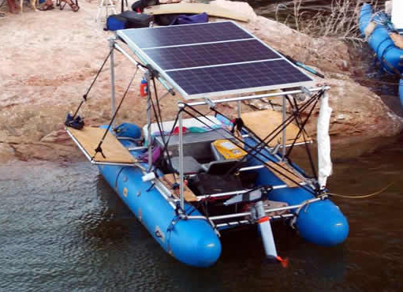
The solar raft on a previous trip across Lake Powell.
The Down the Colorado expedition began on June 15, 2012 at the headwaters of the Colorado River in Rocky Mountain National Park. The researchers then floated for two months until they reached Lake Powell, Utah. The objective of the project is to make the voices of various stakeholders and “river experts” heard, as well as providing a virtual tour of the Colorado River through narratives, interviews with basin stakeholders, photographs, videos and scientific research. This information will then be combined to create the centerpiece of the expedition, an interactive map of the Colorado River Basin that will allow the public to experience the river alongside the researchers. So far, the field researchers have hiked, pack-rafted, kayaked and rafted 500 miles of the river, beginning at its source in Rocky Mountain National Park.
Throughout the expedition, the researchers are measuring dissolved oxygen, temperature, salinity, pH, nutrients and turbidity each day, offering a finer resolution of data than is currently recorded at USGS gauging stations. Partnering with Marine Ventures and Below the Surface, a river conservation group, researchers will create an in-depth geographical overview of Colorado River basin which will be made public upon completion. Videos produced by the expedition covering interviews with the basin’s stakeholders also will be embedded on the map and later produced into a full-length documentary to raise awareness of Colorado River issues.
For photos and more information, visit: http://www.stateoftherockies.com/ or http://www.downthecolorado.org/.

About the State of the Rockies Project
The State of the Rockies Project is a student-faculty collaborative research initiative of Colorado College seeking to increase public understanding of vital issues affecting the Rockies. The Project team, including Colorado College undergraduate students, recent graduates and faculty advisers, conducts extensive research and creates a comprehensive report on the region. Findings are reported and published in the annual State of the Rockies Report Card. For more information, visit www.stateoftherockies.com.

About Colorado College
Colorado College is a nationally prominent, four-year liberal arts college that was founded in Colorado Springs in 1874. The college operates on the innovative Block Plan, in which its approximately 2,000 undergraduate students study one course at a time in intensive 3½-week segments. The college also offers a master of arts in teaching degree. For more information, visit www.ColoradoCollege.edu.

