GOVERNMENT DOCUMENTS Report:

the Federal Depository library Program
at COlorado College

HIstorical overview

Colorado College has been a selective depository for federal documents since 1890. Starting just a few years after the founding of the College, the U.S. Government Documents Depository Collection has served the needs of the College, general public, and 5th Congressional District. The library does not own these materials but is a steward of the collection and must comply with federal regulations and codes.
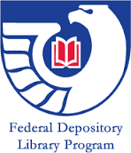
Of the publications offered from the Government Printing Office, (GPO), the library has continuously selected between 25 and 36%. Due to a founding gift and subsequent donations, publications in the collection include items predating the founding of the college and date back before the establishment of the Federal Depository Library Program (FDLP). Additional gifts and special purchases have led to a collection strong in publications of the Congress, Smithsonian Institutions, Census Bureau, Departments of Education, Environmental Protection, Labor, Justice, Interior, State and some areas in the Departments of Agriculture and Treasury.
The collection currently contains just over 117,000 items. This is down from nearly 2865,00 items in 2007. The collection includes maps. Maps published by the U.S. Geological Survey (USGS) comprise most of the map collection. Also included are maps from other U.S. government departments along with privately published maps. Most recently they have been located in a designated map room along with some atlases from the main collection and globes which were checked out to faculty for blocks at a time.
The collection includes a variety of physical and virtual formats. Since the late 1990s GPO has been distributing increasing numbers of publications online and in digital formats. Outdated formats (micro-cards, floppy discs and VHS tapes to name a few) have been withdrawn and substituted with electronic versions when possible. The department has been receiving fewer print publications. We no longer receive microfiche. We continue to receive maps, DVD/CD-Roms, and from time to time, kits. In the past formats have included jigsaw puzzles, 3-D models, and flash cards.
The Government Documents Department has been a small library housed within the larger Library. As such, it has been able to contribute in multiple ways to the service and learning goals of the library as it bridges both technical and public services. Over time, work of the government department staff has gone from working in that one department to being shared with technical services staff and at public service points. The link between the two is important in a small academic library where having access and understanding the best practices to provide access go hand in hand.
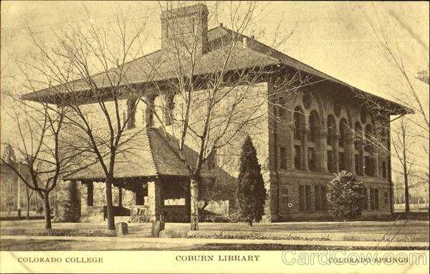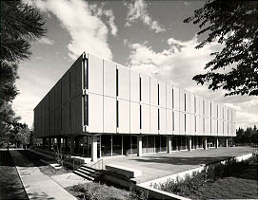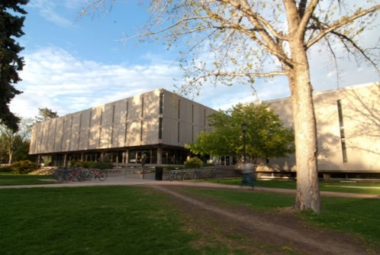
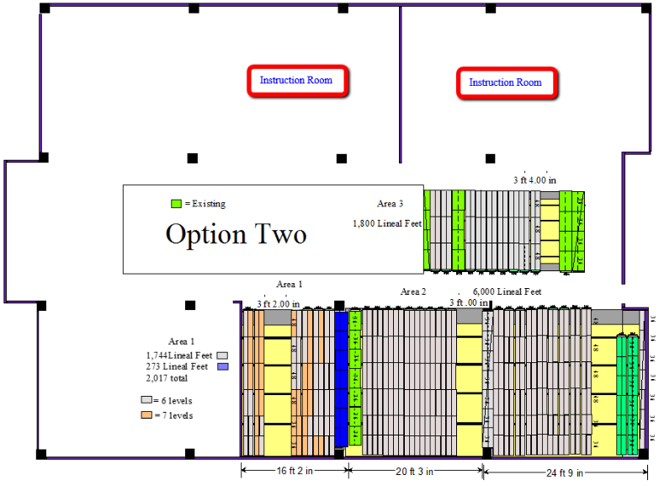
The collection has changed locations in the library multiple times. At first it was housed in the College’s Coburn Library which no longer exists. After Tutt Library was constructed through the 1970s, most of the collection was housed on the third floor with maps and some other USGS documents in the basement. There were also reference materials on the first floor neighboring the LC reference stacks. The collection was later moved the first floor of the south addition and the maps were reunited with the rest of these materials.
In 2003, it was decided that a Learning Commons would be housed in the first floor south level of Tutt Library. This was the location of the FDLP collection. A concentrated weeding project was undertaken to fit the collection into 9,817 linear feet of compact shelving in Tutt South Basement.
In 2014 plans to remodel the library building led to additional weeding. Approximately 2,000 linear feet remained in place while the rest along with the map collection moved to a new storage facility, Creekside. The government documents not at Creekside will be moved to the new library along with the maps. The documents at Creekside will
remain there.
FDLP Collection in Tutt South Library
Also housed at Creekside is a growing collection of Colorado documents. State publications are also located in the LC Collection, Special Collections, and reference materials.

Public Services

Research service and helping patrons access the collection has been a major concern for library staff from the start. Government publications were not represented with cards in the library’s card catalog and required a librarian’s help to locate them. A separate item level card catalog used for processing served as the record of recent for publications. Until 1992 when the library began receiving marc records, documents were not included in the online catalog. Currently not all the collection is cataloged and a separate card catalog still exists; it had been located in the Government Documents Department Office and now resides in the Technical Services Office.
Staff at a separate Documents Desk provided assistance to patrons needing help with federal information until the summer of 2005. The last full year of reference statistics logged at this service point included 139 in-person and phone inquiries. At that time the collection was relocated to the south basement and a map room was created on the first floor south. With this change, the Documents Desk and government research services were folded into the library’s a centralized main research desk.
Brochures and guides to accessing materials in the FDLP collection have been critical to using the collection. Government Documents Web pages have been created since the late 1900s. In the 2000s those web pages were migrated first to a wiki and later, in the 2010s, to LibGuides. Guides to the collection both online and in paper continue to be written and updated.
Book displays were another means of highlighting the collection. Most frequently student workers in the department created exhibits to match course content. Creating displays ended when the space changed after the creation of the Learning Commons on the first floor. There was no longer a display space in the department.
Instruction and training has also been part of the department’s role. In addition to working with classes as part of the library’s instruction program, sessions have been offered to the CC Community highlighting government publications. Other presentations to the campus highlighted specific parts of the collection. And a variety of training sessions have been offered to staff.

For a while, a centralized legal research collection served as outreach to public users. It was dismantled when the collection moved in 2004. In the past the library engaged in shared housing arrangements with Penrose Hospital and the Pikes Peak Library District. These ended in the 2000s when many items Tutt Library was selecting for those organizations shifted to online internet access.

During the building remodel, federal and state government publications have been available via request through the TIGER catalog. This service will continue since many of those publications will remain off-site. Campus constituents and community users will continue to need support and help in using the collection.

Technical Services

Managing the collection has several layers. There is the daily routine work of receiving, processing, cataloging new documents, and weeding of non-essential documents. These tasks have been coded into a Docs Procedures Manual which is updated periodically. There are regulatory requirements some of which repeat such as the annual item selection review and a biannual survey sent to all FDLP Libraries from GPO.
Staffing for the department has waxed and waned over the decades. New tasks and technological advancements for the library have impacted the level of staffing. The department has downsized from a dedicated librarian and full- time coordinator along with 6-8 student workers to a librarian with split job duties, a part-time position now covered by a few hours of non-exempt staff time and 2-3 student workers. Student workers receive training in all aspects of processing depository materials including copy-cataloging and working in the ILS.
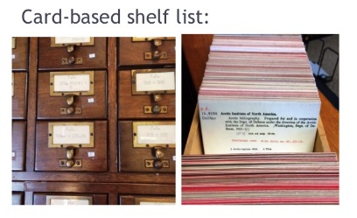
Cataloging the collection has been an on-going activity. In 1992 the library began purchasing marc records and adding them to the TIGER catalog. This is done through weekly batch loading of records from a third party vendor, Marcive, who uses the selection profile the library renews every year with GPO. The library financially supports our regional library in cataloging unique items and then used those records for our own collection. In the early 2000s, a retrospective conversion project was undertaken. Based on Tutt Library item selection records, 90,000 records were added as suppressed records to the catalog. These records represented the library’s item selection from GPO between 1975 and 1991. This projected was finished in the summer of 2014. GPO’s transition to electronic depository collections has resulted in more Internet access as well as an increase in the digital records that contain links to web sites and are accessible through TIGER. So now, most government resources, including the historical legacy collection, are accessible through the TIGER catalog.
The collection has been honed through several large scale acquisitions and multiple weeding projects. FDLP Collections at a branch of the Denver Public Library, a Jeffco Branch Library, and the Library at Adam State University have undergone downsizing in the last 15 years. In each instance, Tutt Library received withdrawn items from those collections enabling us to fill in missing items and acquire documents no longer in print. A massive weeding project was undertaken in 2004 to move the collection on to 10,000 linear feet of compact shelving. Approximately 11,000 titles were withdrawn chiefly paper (not microfiche). Along with that move, a map room was created and all maps were cataloged. Thaat space was finished in 2006. To accommodate space issues in the remodeled library building in 2016-17, the collection needed to be reduced further. The college provided supplementary funding to purchase a large amount of periodical literature and several federal publication databases. Backfiles of the Congressional Record, the U.S. Serial Set and legislative committee hearings were added to the library’s databases. Access to those materials not only increased, but also the library gained nearly 2,400 linear feet in shelf space. With that fantastic acquisition and further weeding, 135,762 titles in both paper and microfiche were removed from the collection between May of 2014 and April 2016. Looking to the future, GPO will soon launch a new processing tool to aid in the deaccession and acquisition of federal publications. This will offer the library new means to continue building and refining the collection.
Other department activities involve attending intra-library meetings and events and participating in initiatives. A consortium project in 2010 was the direct result of the collective purchase of a high speed microform scanner by the Alliance. We are able to get digital copies of FDLP materials from our regional at University of Colorado, Boulder rather than rely on microfiche. This lead to the withdrawal of 2/3 of our microfiche holdings during the 2016-7 weed for the building remodel without comprising our ability to provide our users with these documents. And in fact, it lets us enhance our service by offering a superior product of electronic access rather than in-house microfiche use. With both Prospector and informal interlibrary loan requests between the regional documents department and other selective departments within the state, our community has access to the full gamut of FDLP items.

Professional Services

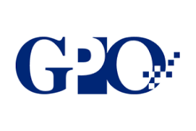
Documents Librarians at Tutt Library have participated at the national level with GPO and at federal conferences. They have participated in related professional organizations. They have presented and published in areas of interest to documents librarians such as moving a documents collection, preserving maps, and depository collections in the 21st century.
Documents Librarians have also participated in a state wide interest group, COGoPub, for several decades. This has resulted in collegial relations between institutions in the state and region. Projects untaken by this group include several multi-institutional activities and events including an IMLS Grant (Government Information in the 21st Century), the founding of a bi-annual regional virtual conference, a shared state collection plan and MOU, and the collaborative collection development. The group also shares best practices for daily management of the collection and supervision and training of staff.
When interacting outside the campus’s boundary, the Documents librarians have served as ambassadors to partners in the state and region as well as on a national level. This has led to multiple benefits that transcend traditional technical services/public services silos. They range from inspiring people to engage with one another, to fostering dialog around trends and regulations, to enabling greater geographical coverage, to establishing relationships between members of institutions that have led to other work and projects, and more collaborating within the group. Such engagement among document librarians helped to create a network of people who exchange expertise and knowledge.

Future Initiatives

The FDLP collection at Colorado College is a special collection. Few libraries participate in the FDLP and even fewer have a collection as rich as this one at Tutt Library. CC emphasizes place in its mission and has programs tying it to the southwest. The federal government and state collections mirror that concentration and should continue build in these areas of interest to the college and region. Ongoing partnerships with GPO and the CoGoPub group will serve the library well in this regard.
A significant part of the physical collection is housed in the Creekside facility. Fortunately, much of the collection has been cataloged. Continuing efforts will led to a completely cataloged collection. There is space available at the facility to further expand in significant areas. Becoming a GPO partner as a Preservation Steward for specific parts of the collection would be worth considering and is a recommendation moving forward.
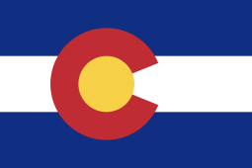
In keeping with CC’s role in the region, another recommendation would be to become a state depository. Over the years, the Colorado State Document Collection has grown. Not all libraries in the state have these publications. As more and more of these publications are born digital and available via batch loading, it would be advantageous and not require a great deal of effort to add these records in the library’s catalog. With the withdrawal of over 140,000 “td” (docs) records in the TIGER catalog, adding in records for state publications would greatly enhance access for our campus to these materials.
Along with being a good steward of the collection, Tutt Library and Colorado College has a duty to provide citizens with access to government documents and publications. After a century of housing this collection and providing access to it, Tutt Library with the re-opening of its remodeled doors, is well positioned to continue the College’s tradition of offering valuable service to the campus and region.

