PRINCIPLES OF ECONOMICS LAB – SUPPLY AND DEMAND ANALYSIS II
Comparative Statics

OBJECTIVES: The purpose of this lab is to use “absolute” and “relative” cell references in Excel to perform comparative statics in a supply and demand model. Students will create formulas, tables and alter parameters to see how important factors affect supply, demand and equilibria. This lab expands upon the supply and demand analysis from Supply and Demand Analysis I.

- Create Demand Worksheet
In this section, we utilize the supply and demand model from the Lab IV given by

Qd = 20 – P and Qs = -10 + 2P.

Rather than taking the constant terms (in our case, 20 and –10) as given, we break them up into familiar “shift” parameters (those that cause a shift in demand as opposed to a movement along a demand curve).

- Open a new workbook in Excel and name the file “Supply-Demand-II-Name”. (Type your name for “Name”.)

Let us begin with demand. Assume the constant term in the demand equation, 20, includes the shift parameters income, W and the price of related goods, Pr. The demand function takes the form

Qd = a*W + b*Pr – cP

where the parameter a indicates how quantity demanded is affected by income; b by the price of related goods; and c by a change in own price. Now let’s create a table of variable and parameter data.

- First type “Parameters” in cell A2 (format the text using the bold button, , and underscore button, ), “a = “ in cell A3, “b = “ in cell A4 and “c = “ in cell A5. Next add “Variables” in cell A7, “W = “ in A8, “Pr = “ in A9. Note that these are not formula’s, because they do not begin with the equals sign.
- Now add values for the parameters (a, b and c) and values for the variables (W and Pr) by typing “2” in B3, “1” in B4, “1” in B5, “7” in B8 and “6” in B9. The sheet should look as follows. (To bold and underline the text click

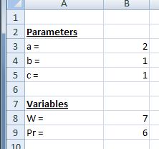

- Next create a table of 20 data points for price and quantity demanded. Type “Price” in cell D2 and “Qd” in cell E2. Generate columns of data for price and quantity demanded ranging from 0 to 20 by increments of 1. As done in the previous lab, use Excel’s automatic fill feature by typing 0 in cell D3 and 1 in cell D4 (rather than entering each number) and then highlighting the two cells and “dragging”. Refer to step (d) in Lab IV for detailed explanation of procedure.
- To generate data for quantity demanded we use both “Absolute” and “relative” cell references. Up to this point, we have denoted cells simply by their column and row, e.g., A4 refers to the cell in the first column and fourth row. Clicking and dragging such a cell creates a new series of cells that change relative to the initial cell. This is known as a relative cell reference. Placing a $ in front of the column and row designation creates an absolute cell reference. Thus, A4 is a relative cell reference while $A$4 is an absolute cell reference. The cell reference is absolute in the sense that it is not dependent on the cell in which the formula appears. Clicking and dragging on the cell will create a series of cell unmovabely linked to A4. You can toggle between cell reference styles (absolute, relative) by pressing F4 when you have a cell highlighted. In the first cell of quantity demanded data, E3, we type the formula for the demand function

=$B$3*$B$8+$B$4*$B$9-$B$5*D3

(= a * W + b * Pr – c * P)

Note that D3 is a relative cell reference to price (which is a variable that changes from cell to cell) while $B$3 is an absolute reference to the parameter a, 2. (Absolute cell references were ignored in previous lab because constants were used for intercept and slope parameters, i.e., Qd intercept was 20 and slope was (-)1.)

Q1: What is the quantity demanded for a price of 0, 5 and 15?

- Create a plot of demand in the worksheet with axes ranging from 0 to 25. Put “Price” on the vertical axis and “Quantity” on the horizontal axis. (Refer to Lab IV for detailed explanation of procedure.)
Q2: Assume that income doubles. What is the quantity demanded for a price of 0, 5 and 15? Is this good income inferior, neutral or normal?

Q3: Assume that Pr doubles (income remains at its initial level of 7). What is the quantity demanded for a price of 0, 5 and 15? Is the related good a substitute or a complement? Explain.

- Create Supply Function
We repeat the steps above to create a column of quantity supplied data and plot. First let’s create a table of variable and parameter data.

- Type “Parameters” in cell A11, “d = “ in cell A12 and “e = “ in cell A13. Next add “Variables” in cell A15 and “Pi = “ in A16. Apply the same formatting as above for the text “Parameters” and “Variables”.
- Now add values for the parameters the variables by typing “-2” in B12, “2” in B13, and “5” in B16.
- Assume supply is a function of price, P, and the price of inputs, Pi of the form

Qs = d*Pi + e*P

where the parameter d indicates how quantity supplied is affected by input prices and e by a change in own price. Type “Qs” in cell F2. Use Excel’s automatic fill to generate a column of data for quantity supplied ranging from 0 to 20 by increments of 1 in column F. (Make sure to change the demand parameters and variables back to their initial values.)
- Add the supply curve to the demand plot with both axes ranging from 0 to 40.

Q4: Find the equilibrium price and quantity from the table and copy and paste that row into your homework sheet.

Q5: Assume the price of inputs rises to 8. Find the equilibrium price and quantity from the table and copy and paste that row into your homework sheet.

- Add the supply curve to the demand plot by right-clicking on the graph. From the menu that appears, choose Select Data and then follow the familiar graphing steps of adding a new series (i.e., quantity supplied). Set the scale minimum to zero for the horizontal axis. (This restricts the plot to the positive quadrant.)

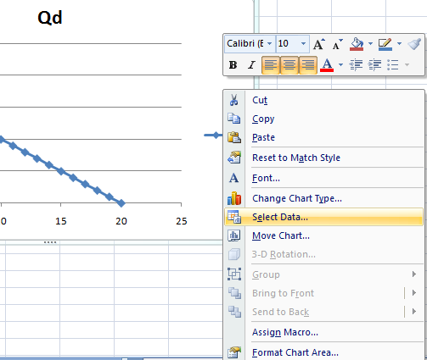

Q6: Assume the price of inputs rises to 11. Find the equilibrium price and quantity from the table and copy and paste that row into your homework sheet. Include the plot also.

Q7: Type in the initial parameter and variable values for supply and demand. Assume that income doubles and the price of inputs rises by 50%. Approximate the new equilibrium price and quantity from the table (i.e., explain it as “P is between ___ and ___ and Q is between ___ and ___”). Solve for the actual price and quantity by hand rounding to two decimal places.

