Instructions for Thank You Notes for Music Lesson Scholarships
- Recipients of scholarships are required to write a thank you note
- Your donor fund information is on your completed registration-Financial Aid Requested form
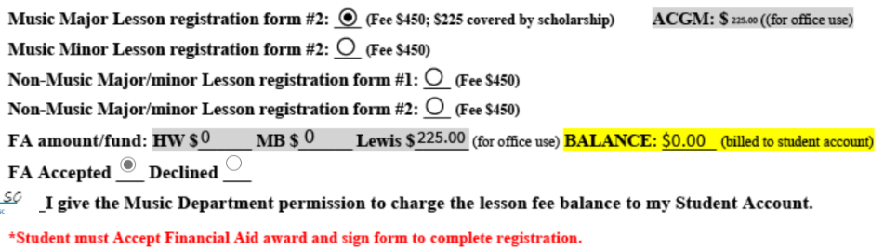

Donor Fund: HW=HORACE WORKS/ MB=MYRTLE BRIDGES/ Ida Whitsitt Lewis=LEWIS

- Next page: Template to assist in completing note.
- Return completed Thank You Note to musiclessons@coloradocollege.edu as Word or PDF attachment or in the body of the email.
- Deadline for thank you notes: end of block 1/block 5
- Failure to complete and submit Thank You Note puts future financial aid requests/awards in jeopardy.

Suggestions for writing thank you note:
-Describe how you have benefitted from this music lesson.
-How this instruction/experience has enriched your life.
-What it means for you to take lessons.
-Describe appreciation for financial assistance making lessons possible.
-The note need not be elaborate, as long as it is sincere and, hopefully, written soon!

HORACE WORK FUND Thank You Template
(copy and paste this template– do not copy this title)

(Type in today’s date)

Mr. and Mrs. Horace Work
P.O. Box 6929
Snowmass Village, CO 81615-6929

Dear Mr. and Mrs. Work,

Sincerely,

(your name)

Ida Whitsitt LEWIS FUND Thank You Template-
(copy and paste this template– not copy this title)

(Type in today’s date)

Mr. John L. Chambard
PO Box 4292
Cary, NC 27519

Dear Mr. Chambard,

Sincerely,

(your name)

