Physics For Everyone
http://www.coloradocollege.edu/Dept/PC/RepresentativePhy/home.htm
Energy Problems
August 1, 2005

Section 1: Work
1.1 Flour Power
Hal has bought some flour to bake his grandmother a cake. He starts up the stairs to her fourth floor apartment. Each flight is 10 vertical ft, and it takes Hal 15 s to climb each flight. Unfortunately, just as he starts to climb the stairs, the bag develops a small hole and by the time he has reached the top of the stairs he has only 3.2 lbs left.
- If the bag is 5 lbs to begin with, how fast is the flour leaking out?
- Assuming the rate of leakage is constant, how much work does he do on the bag carrying it up the three flights to his apartment?
- How much work would he do if the hole were bigger, and it is leaking at .12 lb/s?

1.2 Mental Labor


Physics students are frequently told that the mental labor involved in doing physics homework is not “real work” according to the physics definition. Let’s investigate how much work mental labor really involves. The average blood flow through the brain of a human adult is 12.5 mL/s, and its density is about the same as water. However, when you are doing a cerebrally intensive task, the rate of blood flow can increase by as much as 25% to supply your mind with the necessary oxygen. Assume a physics problem stretches your mind as much as possible and you require this maximum amount, and you spend 30 min working on it. If you tend to do your homework sitting upright, how much more work does your heart do pumping the blood to your brain while you are working on that problem than when you are just relaxing?

1.3 Hiking Pike’s Peak

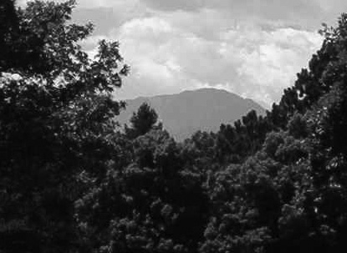
Luisa and her friend Miguel have decided they want to hike up Pike’s Peak. Luisa has done some research and decided that they will go up the Barr Trail, then come part way back down and meet her dad at the Crags parking lot. The Barr Trail is 13 miles each direction with a vertical gain of about 7000 feet, and the trail back to the parking lot is about 6.5 miles and 4200 feet vertical. However, the path up contains numerous switchbacks that vary from very steep to completely flat. They also must work much harder to climb as they get up into the thinner air at higher altitudes. Luisa weighs about 140 lbs and Miguel weighs about 180 lbs, including equipment.
- Approximately how much work against gravity did each of them do?
- Is this the same as the actual work they did? Why or why not?
- Where did the energy they used come from?
d) What happened to the energy not used to do work against gravity?

1.4 Sledding
Cory and his big sister Sam are going sledding. Sam is pulling the sled up the hill, when Cory jumps on it and asks her to give him a ride to the top. The mass of the sled when Cory is on it is 30 kg. The slope of hill is about 25º up from the horizontal, and it is about 6 m high. Sam pulls on the rope at an angle of 20º to the movement of the sled, as shown. The coefficient of friction between the sled and the snow is .1.
- How much work does Sam do pulling Cory up the hill, if the sled moves at a constant velocity?
- Sam accidentally drops the rope just before they reach the level ground at the top of the hill and Cory slides backwards. How fast will he be moving when he gets to the bottom?

20º

25º

1.5 Painting a Ceiling

Sarah is painting a vaulted ceiling, where the two sides of the ceiling make an angle of 120 degrees with the walls. She starts each stroke with the long-handled roller at an angle perpendicular to the ceiling, then drags it until the roller is pointed directly overhead, as shown below. The point around which the roller pivots is exactly 3 m straight down from the ceiling. If she applies a constant force of 100 N in the direction of the roller, how much work does she do for each stroke she paints?

120º

3 m

Pivot point

Section 2: Kinetic and Potential Energy
2.1 Wingardium Leviosa
In Harry Potter and the Sorcerer’s Stone by J.K. Rowling, Ron Weasley manages to knock a troll out by levitating its club and then dropping the club on the troll’s head.
- If the troll is 12 feet tall and Ron manages to drop the club, weighing 50 kg, from 15 feet in the air, how much kinetic energy will it transfer to the trolls head when it strikes?
- If the troll’s head brings the club to a complete stop before it continues to the floor, how fast will the club be moving when it hits the floor?

2.2 Valentina’s Flight
The first woman in space, cosmonaut Valentina Tereshkova, flew in 1963. She orbited the earth 48 times during her 70 hour 50 minute flight at an average altitude of 165.5 km above the surface of the earth. Her spacecraft, Vostok 6, had a mass of about 4700 kg.
- What was her average kinetic energy in this flight?
- What was her average gravitational potential energy? Is she high enough that the gravitational field strength is different from what it is on the surface of the earth)?

2.3 Aswan High Dam
The Aswan High Dam in Egypt, built from 1960 to 1970, is an engineering masterpiece, though it has caused environmental and cultural problems in the surrounding area. It increased the amount of cultivatable land in Egypt by 30% and produces 2.1 GW of power, but over 90,000 people were displaced by Lake Nasser, the reservoir formed by the dam. Also, about 12% of the water held in the lake is lost to evaporation. This enormous structure generates power by letting the waters of the Nile fall from a height of 111 m.
- How much water goes over the dam each second?
- How fast is the water falling when it reaches the base of the dam?

2.4 Visit to Vesta
You are the first person to set foot on the asteroid Vesta, on of the largest asteroids in the solar system with a mass of 3.0 x 10²⁰ kg and a radius of 265.5 km.
- While taking pictures from the asteroids surface, you drop your camera. How fast is it moving when it hits the ground?
- After gathering all of the information and pictures you need, you climb back into your spaceship to go home. How fast must you take off to escape the asteroid’s gravitational pull?

2.5 Making a Skirt


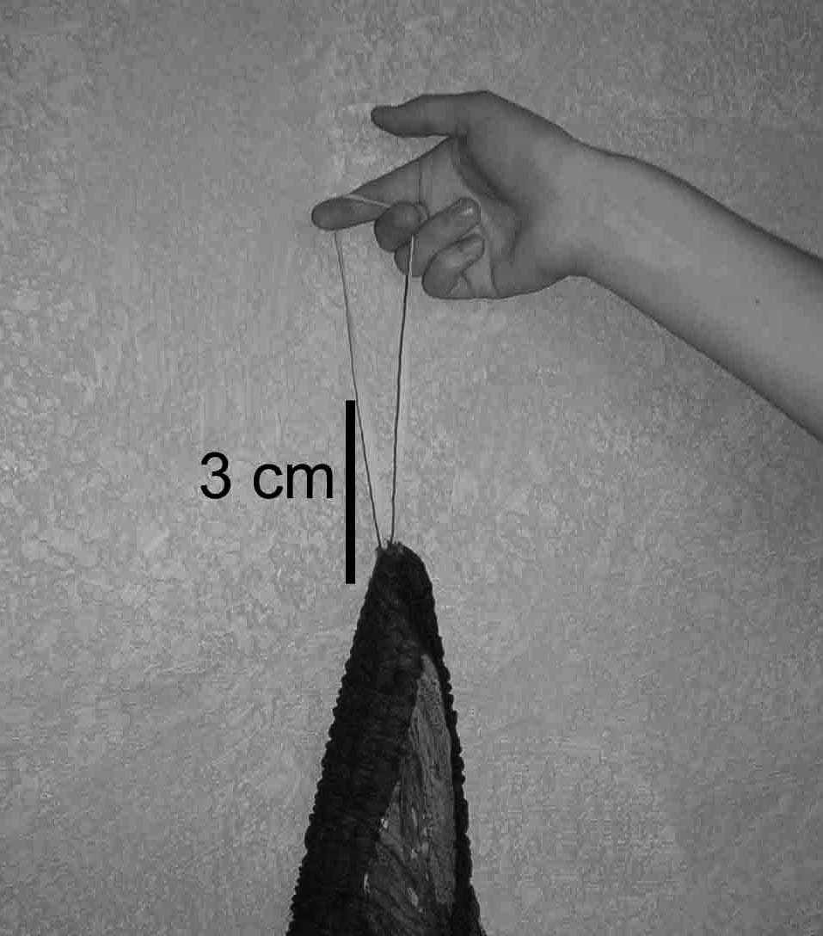
Erika is sewing a 75 cm piece of elastic into the waist of a skirt she is making. After she has threaded it through the skirt and stitched the two ends of the elastic together, she notices that when she holds up the skirt by the elastic alone the loop stretches 3 cm towards the floor.

- If the fabric of the skirt has a mass of .5 kg, what is the spring constant of the elastic?
- How much potential energy does the elastic have when she pulls the skirt on over her head, stretching its circumference to 90 cm?

2.6 Bungee Race
Between periods of hockey games, bungee races are a fun but silly way to keep the crowd entertained. A few lucky fans get hooked to bungee cords and have to run across the ice to retrieve their prizes. Of course, they tend to lose their footing and get pulled back to the starting point. Tom, whose mass is 80 kg, is selected to participate. He runs across the ice and manages to stretch the bungee cord, with a spring constant of 100 N/m, 3 m longer than its normal length of 5 m before falling.
- How much work did he do on the bungee cord?
- The coefficient of friction between the ice and his pants is .08. What is the fastest backward speed he attains?
- At what point does he stop moving backwards?
- How much work did the bungee cord do on him?

Section 3: Conservation of Energy

3.1 Moving Day
Jane is moving to a new house for the summer from her current basement dwelling. She lifts a box weighing 21 kg about 3 ft, then carries it up one flight of stairs. However, when she reaches the top of the stairs, she drops the box. First it falls straight down and strikes the top step, then, after an agonizing moment of teetering on the edge, it slides all the way back to the bottom.
- How much work does she do to carry it up the stairs?
- How fast is it moving when it hits the top step?
Neglecting friction, as the stairs were recently waxed, how fast is the box sliding when it gets back to the basement floor?

3.2 Snowball Fight
Xiang and her cousin Li Hua are having a snowball fight on a frozen pond near her house. Xiang has retreated behind a tree and Li Hua is advancing towards her across the pond. Xiang hopes to force her back, so she makes a huge snowball with a mass of .23 kg and throws it at Li Hua as fast as she can, about 7 m/s. When the snowball hits Li Hua, about 1% of its kinetic energy is conserved.
- Neglecting friction, how fast does Li Hua, who has a mass of 35 kg, slide backward?
- How much warmer is the snowball after it comes to rest on Li Hua?

3.3 Monkeying Around
A little spider monkey (let’s call her Flo) has stolen a bunch of bananas from her older brother Charley and is now running away from him with the bananas in hand. She sees salvation in a long vine and grabs the bottom, hoping to swing away.
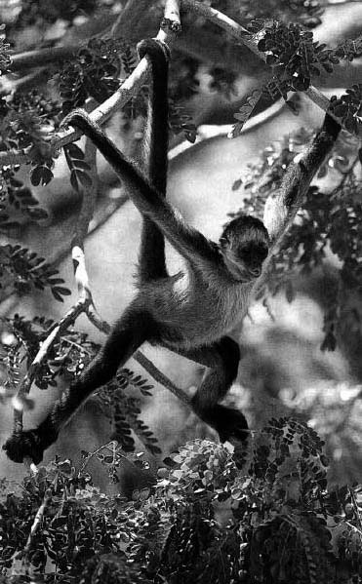
- If Flo, who has a mass of 5.3 kg, and the bananas, with a mass of .5 kg, reaches a height of 1.2 m before slowing to a stop and swinging back down, how fast was she running when she grabbed the vine?
- As she swings back down, Charley (whose mass is 5.9 kg) is standing just at the bottom of the swing. He grabs her and they swing up together. What height will the two monkeys and the coveted bananas reach?
- As a result of their fighting, they happen to drop the bananas just as the vine pendulum reaches this new height. How fast will the two monkeys be moving when they let go of the vine at the bottom again?

3.4 Skiing
Sarah and her family are skiing at Monarch. At one point on Sarah’s favorite run there is a small rise of 2 m vertically, so Sarah and her mom have to start building up speed in order to make it over this hill.
- Neglecting friction and air resistance, what is the lowest point on the preceding slope where they can turn or break, and still make it over the rise at C?
- In that case, how fast will she be moving at B, the lowest point she reaches?
- Of course, friction and air resistance are non-negligible in this case, as Sarah learns when she comes to a stop .8 m below the crest of the hill. If she weighs 578 N, how much work must she do climbing to the top?

Section 4: Thermal and Chemical- Energy
4.1 Fueling a Thunderstorm
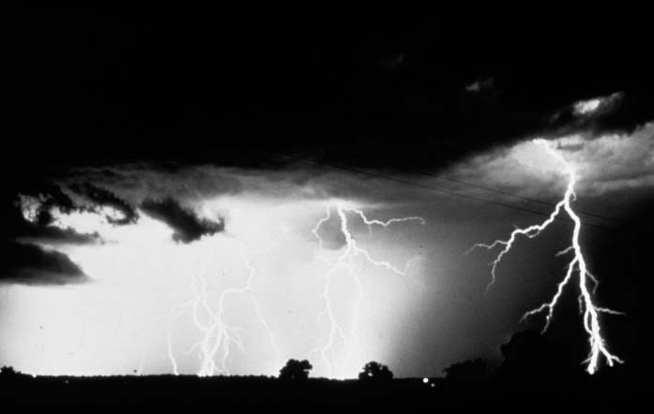
Scientists say that the energy in severe thunderstorms comes from the heat released when water vapor condenses into liquid. If a powerful thunderstorm releases 10 million kilowatt-hours of energy over the course of an hour, what volume of water must have condensed?

4.2 Bake Time
Hal has just finished baking his grandmother’s cake. His apartment is very hot, and he does not want the oven’s heat to make him any more uncomfortable, so he decides to put a pan of water in the oven to “soak up” the heat. When the oven and water are the same temperature, Hal pours the water outside on his garden. The initial oven temperature is 325º F, and has a volume of 0.968 m³. Inside the insulation, the oven consists of 24 kg of stainless steel. Hal puts in a pan of water at 50ºF. The stainless steel pan has a mass of 600 g and holds 2 L of water.
- If the oven is not airtight and the molar mass of air is 28.98 g/mole, what is the initial volume of air in the oven?
- Assuming the oven is perfectly insulated, what is the final temperature of the water when Hal pours it out on his garden?
- Does the air in the oven contribute significantly to the heat? Why or why not?

4.3 Photosynthesis
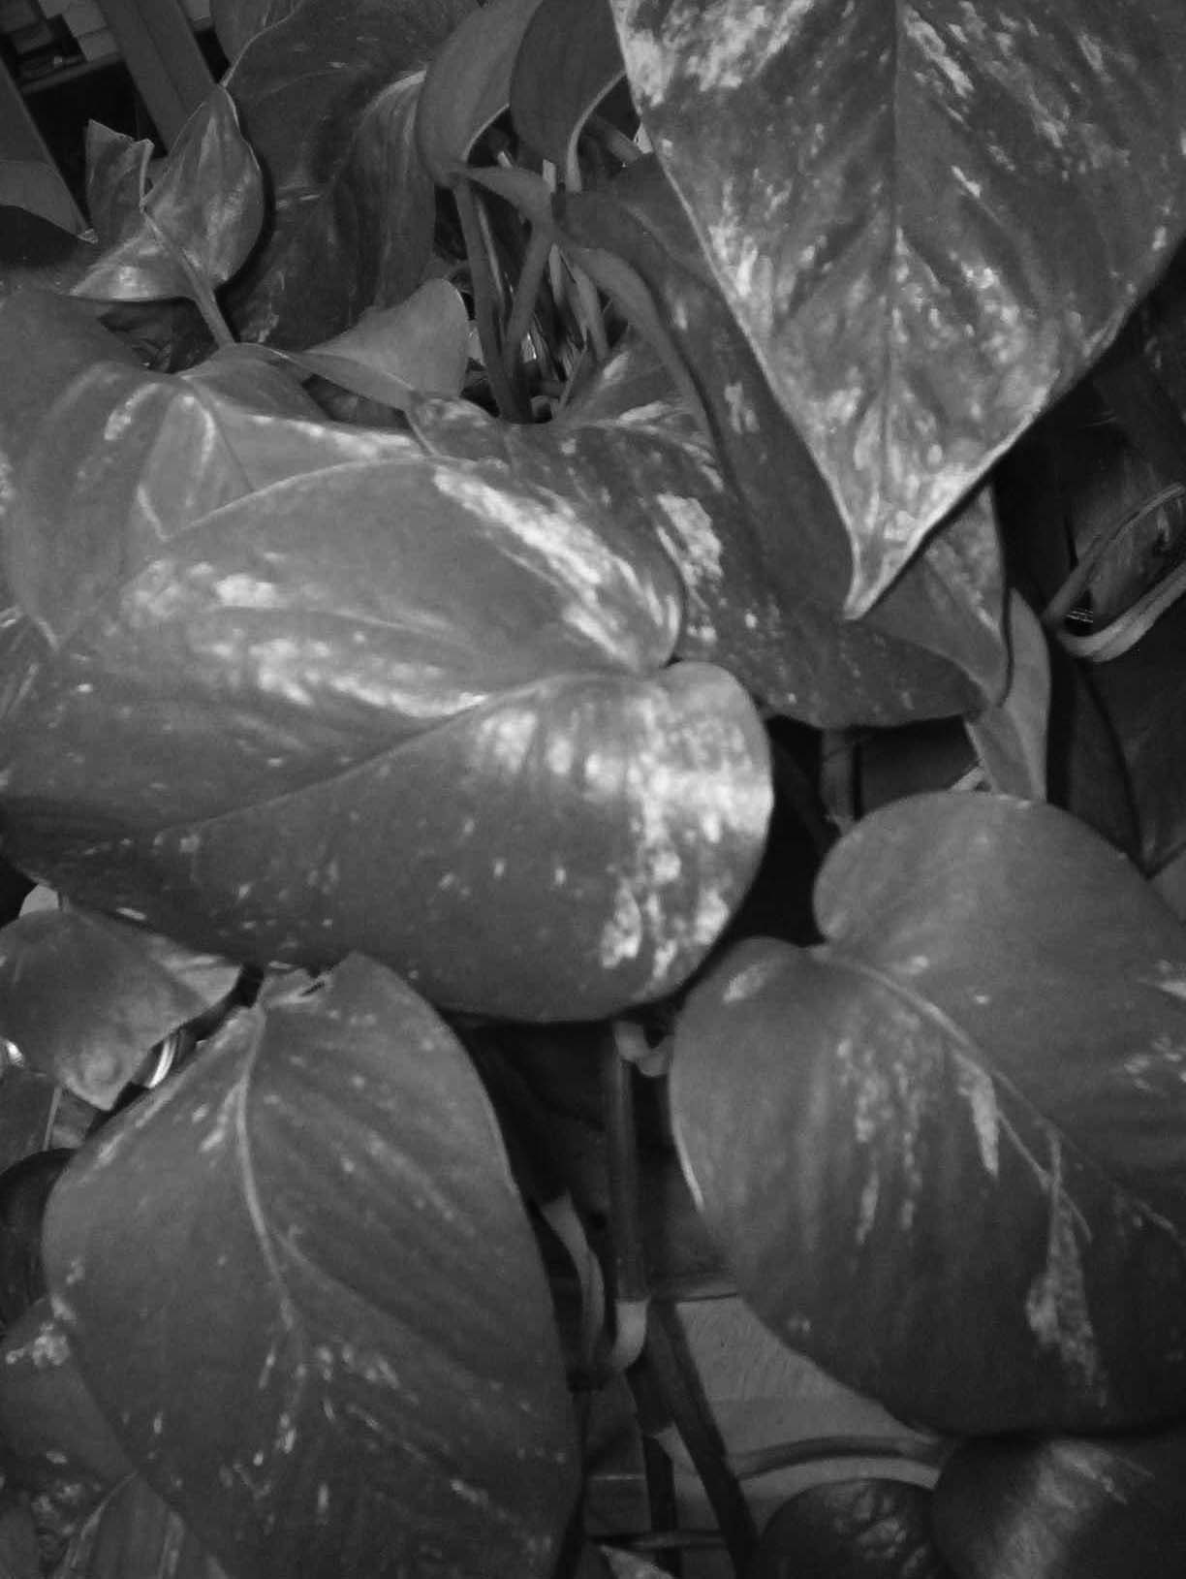

Green plants have the incredible ability to trap energy from the sun by the process of photosynthesis. The general equation for this reaction is: light + 6CO₂ + 6H₂O → C₆H₁₂O₆ + 6O₂ + heat. The average wavelength of light used in photosynthesis is 690 nm, and it takes 8 photons of light at a minimum to fix each of the 6 required CO₂ molecules in glucose.
- What is the minimum energy it takes to run one reaction?
- Carbohydrates, like glucose, yield 4 kcal/gram. How efficient is the plant’s conversion of radiant energy to chemical energy?

Section 5: Power and Efficiency
5.1 Joe’s Job
Joe the pony is used to help pull water from a well. His owner wants him to pull up large tubs of water, as much as 80 kg, in each load. Joe is a rather petite pony and can only exert .7 hp of power.
- How long does it take him to pull a full tub out of the 10 m-deep well?
- Joe’s owner then decides to rig up a fancy pulley system so that the weight of the water is held on four ropes instead of just one and Joe will have to use less force to pull each load up. Joe is excited, because he assumes he will now have to use less energy to pull up each tub. Explain to Joe why his assumption is wrong.

5.2 The Nuclear Alternative
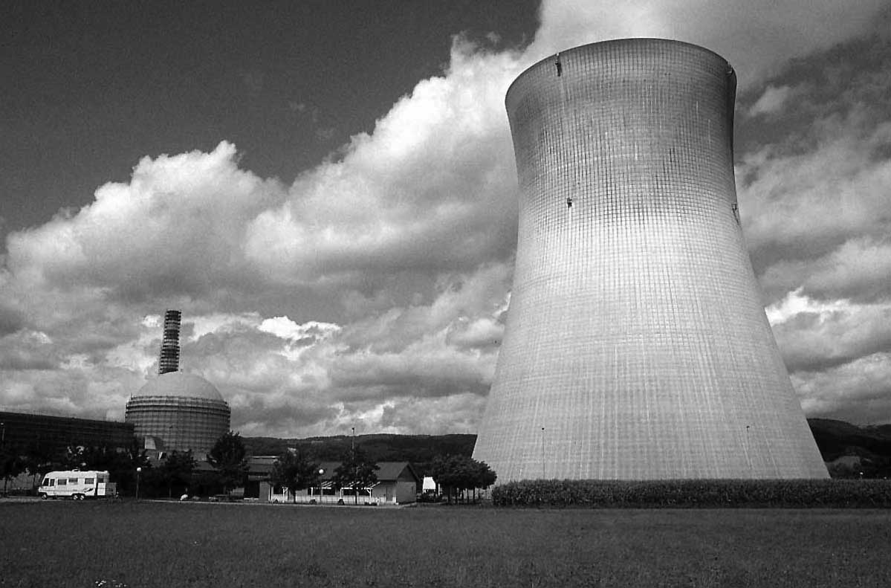
A small town consumes about 10 MW of electricity. Currently the town is using a coal-fired power plant to provide this power, but they are concerned about greenhouse gases and global warming, and are wondering whether to close down their plant and begin to buy electricity from a nearby nuclear power plant. Both plants operate at about 34% efficiency. The coal-fired plant uses coal with an energy content of 29.3 J/kg, and every kg of coal (assumed to be pure C, with a molecular wt of 12 g) produces 3.67 kg of CO₂, while the nuclear plant uses uranium enriched to 4% U-235. A gram of U-235 produces 2.56 x 10¹⁰ J.
- How much coal does the power plant use in a year? How much CO₂ is added to the atmosphere?
- How much uranium is necessary for the town to operate for one year?
- What decision would you recommend? Why?

5.3 Fun in the Sun
Solar energy is one of the most important components of a renewable energy future. Your parents are considering installing photovoltaic cells, which convert the sun’s energy directly into electricity, on their roof, and have asked for your help. You do some research and learn that, on a sunny day in Colorado, sunlight at the earth’s surface provides about one kilowatt/m². Solar panels have an area of 0.5 m², operate at 10% efficiency, and cost $63. Your parents use electricity at a rate of 2 kW.
- If your parents want to rely on solar electricity exclusively, how many solar panels will they need to buy?
- If electricity costs $0.08 per kilowatt-hour, how long will it take your parents to recoup their initial investment?

5.4 Earthquake
The energy of earthquakes comes from the stresses which build up as the tectonic plates on the earth’s surface shift. An earthquake’s strength is typically given on the logarithmic Richter scale. In the past, scientists approximated the energy released by an earthquake from its magnitude, but modern technology allows us to measure the energy released, then determine the earthquake’s magnitude. The old formula for converting Richter magnitude to energy is
log E = 4.8 + 1.5Ms,
where E is seismic energy in Joules and Ms is seismic magnitude.
- Plot a graph of energy released vs. magnitude for magnitudes 4 through eight, increasing by half-integers.
- How long could you run a 60 W light bulb with the energy from an earthquake of magnitude 2? 3? 7?

5.5 MagLev Trains

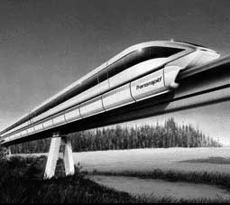
It takes about 560 kW to run a typical diesel locomotive at speeds around 110 mph. Magnetically levitated, or MagLev, trains, on the other hand, require substantially less power because the magnetic levitation eliminates energy loss to friction. The worst MagLev system requires 270 W to levitate the train and 783 W total to move it at 100 mph (fast MagLevs can make closer to 300 mph). The number of passengers each train can hold is comparable. How much less energy does it take to travel one mile in a MagLev train as opposed to one mile in a train pulled by a diesel locomotive?

5.6) Kickball

It is a beautiful day, so Jamal and his friends are playing kickball at the park. Just as he winds up for his kick, the wind, which is blowing directly toward him, suddenly picks up speed. Despite his strong kick, the ball lands barely 10 feet in front of him.
a) What happened? Can you derive an equation to describe the kinetic power of the wind, and explain to Jamal why his kick was not successful? [Hint: Derive an equation for the kinetic energy the wind is delivering to the ball in one second. Consider the kinetic energy in the volume of air that will impact the ball in one second.
A = cross sectional area of ball
Ball
v Δt
wind

5.7) Catching the Wind

Wind turbines are one of the most promising sources of renewable energy today. The problem above shows that the kinetic power of the wind is:

$$P=\frac{1}{2}ρ{\text{Av}}^{3}$$

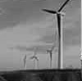
where r is the density of the air, A is the area swept out by the turbine blades, and v is the speed of the wind. Doing some research on wind turbines, you find out the a practical turbine can convert about 40% of that power into electricity. That doesn’t sound like a lot, but is it? If the average household requires 3 kW of power, and the average wind speed is 14 mph, how big a rotor would a household require? (Assume the density of the air is 1.3 kg/m3.)

5.8) Wind Farm

On the bus ride home from school, Ignacio and Mariella pass a wind farm. As they are both taking physics, this is naturally of interest to them. Ignacio says that wind turbines can only convert about 30% of the wind’s power, but Mariella is positive that an efficient turbine can do better than that. Derive an equation for the maximum power a wind turbine can extract, and settle this argument.

A_{b}
A_{t}
A_{a}
v_{b}
V_{t}
V_{a}
Streamline of air moving through turbine
Turbine

5.9) Earthship

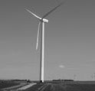
Some friends of yours are planning to build an earthship near Lamar, Colorado, and live off the grid. They would like to install a wind turbine to satisfy their electricity needs, and, knowing you are a physics student, have asked you to help them design their system. You look on a wind map and determine that the average wind velocity at 10 m above the ground in Lamar is 5.2 m/s, and that the air density is 1.0 kg/m3. Small, high efficiency windmills can convert 45% of the wind’s power into electricity. Your friends think that they will need 1 kW of power to meet their needs.
a) How long must the blades on the turbine be to provide them with sufficient power?
b) How much power does the windmill produce when the windspeed is 1 m/s (about 2.2. mph)? 2 m/s? 10 m/s?

5.10) Biking Power
A trained bicyclist in excellent shape might be able to convert food energy to mechanical energy at a rate of 0.25 hp for a reasonable length of time. Imagine such a person pedaling a stationary bike connected to a perfectly efficient electrical generator.
a) Could such a person generate enough electrical power to run a toaster?
b) What about a single ordinary light bulb?

5.11) Hydroelectric Generators
Suppose a hydroelectric generator running on pumped storage is required to provide its full power of 200 MW for a period of 8 hr.
a) What is the total energy, in joules, of the output?
b) Assuming that the generating part of the cycle is 85% efficient, how much energy must be stored in the water in the upper reservoir?
c) If the upper reservoir is 100 m about the power plant, what is the mass of water needed?
d) What is the volume of the stored water?
e) If the water level in the reservoir is allowed to drop 2 m in the 8 hour, what is the area of the reservoir and, if the reservoir is square, how long are the sides of the square?

5.12) Power of the Wind
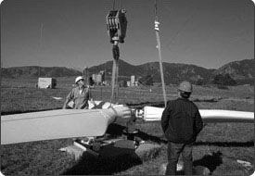
Suppose one has a propeller-type windmill with blades 1 m long. What is the area swept out by the blades? If the overall efficiency of the windmill is 50%, what is the power produced when the wind speed is 1 m/s (about 2.2 mph)? At 2 m/s? At 10 m/s?

5.13) Eliminating CO2
It might be proposed that we eliminate excess CO2 from the use of fossil fuels by shooting it into space. Compare the energy required to do this (that is, the energy required for one kg of CO2 to reach escape velocity of 11 km/s with that obtained from burning the coal that created the CO2 in the first place. Explain why this is not a good idea.

© 2000-2005 Physics For Everyone. All Rights Reserved.

